|  |
| --- |
| HCCOMP2, HCCOMPE2, BSHC2, BSHCE2, BSHTM2 |
| Requirements Specification (RS) |
|  |

|  |
| --- |
| Jane Keyes, Tadhg Savage, Karl Miller, Aisha Ntuli  2/1/2023 |

**Table of Contents**

1 Introduction 4

1.1 Purpose 4

1.2 Project Scope 4

1.3 Definitions, Acronyms, and Abbreviations 4

2 User Requirements Definition 4

3 Requirements Specification 4

3.1 Functional requirements 4

3.1.1 Use Case Diagram 5

3.1.2 Requirement 1 <name of requirement in a few words> 5

3.1.3 Requirement 2 <name of requirement in a few words> 6

3.2 Non-Functional Requirements 7

3.2.1 Performance/Response time requirement 8

3.2.2 Availability requirement 8

3.2.3 Recover requirement 8

3.2.4 Robustness requirement 8

3.2.5 Security requirement 8

3.2.6 Reliability requirement 8

3.2.7 Maintainability requirement 8

3.2.8 Portability requirement 8

3.2.9 Extendibility requirement 8

3.2.10 Reusability requirement 8

3.2.11 Resource utilization requirement 8

4 GUI 8

5 System Architecture 8

6 System evolution 8

# Introduction

## Purpose

The purpose of this document is to set out the requirements for the development of our Virtual Reality (VR) game called “Cooktastrophe”. This game is a simulator for running a restaurant. The user will be allowed to prepare and cook food, serve customers, make money, use money to upgrade various aspects and appliances of the restaurant. The user will be based within the restaurants kitchen where they will have to deal with multitasking. The games difficulty increases as the user progresses through it.

The target demographic for this came is from ages 13 and up. The game is light-hearted and accessible making it suitable for younger teens to grasp while being challenging enough for users of all ages. “Cooktastrophe” will be for all the family to enjoy with its bright colours, Voxel graphic’s, non-offensive music, and entertaining but challenging gameplay.

## Project Scope

The Scope of the project is to develop a VR game.

Group two of the team project module were involved in communications with one another to meet the following requirements.

The system shall have art and graphics developed using Blockbench and will be made using Unity.

Th goals which we are envisioning for this project include modifying Unity’s VR system to suit our game e.g., holding and picking up things. Our deliverables for this project include an initial project proposal, a requirements specification, a mid-point presentation ending with a final software presentation, Report, Application and evidence of communication.

Our tasks include creating the game’s graphics, creating the lore and “world” of “Cooktastrophe” which includes a point system comprised of health bars, money etc. The costs of this endeavour are rather minimal considering that the software we are using on which to make these graphics and the game itself are actually free I would say the only cost we have encountered so far which was also rather optional was downloading the game that our game was loosely inspired by called “Plate Up” to experience the feel and atmosphere of the game and it was under 10 euro. All other costs mostly came down to time costs.

## Definitions, Acronyms, and Abbreviations

**3D** **Three-Dimensional** - This Relates to or denotes a film or video game that creates an impression of depth and solidity, typically by means of stereoscopic techniques.

**Stereoscopic** This relates to or denotes a process by which two photographs of the same object taken at slightly different angles are viewed together, creating an impression of depth and solidity.

**VR**  **Virtual Reality** – This is a computer-generated simulation of a 3D image or environment that can be interacted with in a seemingly real or physical way by a person using special electronic equipment, such as a helmet with a screen inside or gloves with fitted sensors.

**XR** **Mixed Reality** – This is a medium of immersive, computer-generated enviroments in which elements of a physical and virtual environment are combined.

**Voxel** This is a computer-based modelling or graphic simulation. Each of an array of elements of volume that constitute a notional 3D space, especially each of an array of discrete elements into which a representation of a 3D object is divided.

……..

# User Requirements Definition

The user requirements are defined by the set of objects and requirements for the system from the customer’s perspective. In this case the client wants:

* A Virtual Reality game that can be interacted with via VR technology (headsets etc.).
* To be able to communicate with customers in the game.
* To be able to cut and prepare foods and dishes.
* To serve prepared food to customers.
* To take payment from the customer to create an income.
* To view their health status using a star rating.
* To upgrade restaurant appliances using generated income.
* To be able to pause and resume gameplay at their command.
* To be able to turn sounds effects on and off.
* To be able to turn music on and off.
* To end games at their command
* To progress to new levels in the game.
* To begin a new game at their command.

# Requirements Specification

“Cooktastrophe” will begin gameplay with the option of watching an interactive tutorial. This tutorial will breakdown multiple aspects of the game, describing to the user what certain objects are and how to use them. This tutorial should last between 5-10 minutes, after which the user should be able to play the games beginner levels with ease. The difficulty of the game will increase as users progress through it, meaning the more advanced the player, the more advanced the level will be.

## Functional requirements

1. The system must display an initial start-up menu when the game is started up
2. The game must only run on a compatible VR device.
3. The system must begin tutorial round if player chooses tutorial option.
4. The system must begin new game in player chooses new game option.
5. The system must allow the user to take orders from customer.
6. The system must allow the player to prepare the correct food for the customer.
7. The system must display the customers satisfaction to the player.
8. The system must allow the user freedom within the restraints of the restaurant.
9. The system must allow the player to clear dirty tables.
10. The system must reward the player with money if tables are cleared.
11. The system must allow the player to upgrade appliances within the restaurant and kitchen.
12. The system must allow the user to progress to the level when one is completed.

### Use Case Diagram

### Requirement 2 : Tutorial

1. , the system will bring them back to the initial menu.

**Alternate flow**

A1 : Player chooses new game

1. The system starts up with an initial menu screen.
2. The player is presented with two options: Start New Game and Start Tutorial
3. The use case continues at position 3 of the main flow

**Exceptional flow**

E1 : Incompatible drivers for devices

1. The system does not run as it is being run on a device or operating system that is not compatible with the game.

**Termination**

The system presents the next ……….

**Post condition**

The system goes into a wait state

## Non-Functional Requirements

### Performance/Response time requirement

The game should run on compatible VR devices without the interference of bugs or load time. Access to the internet should not interfere with the performance/response time of the game.

### Availability requirement

The game should be readily available to players with a working/compatible VR device.

### Recover requirement

### Security requirement

Users should not be required to input any personal information that may be compromised by malicious hackers.

### Reliability requirement

The game should be able to run at any given time to a player that has the game downloaded and has the compatible VR device.

### Maintainability requirement

**The system should be capable of being maintained cost effectively over its lifespan. Aspects such as debugging, upgrading, expanding, and improving the game should all be considered when maintaining the games integrity and enjoyability.**

### Portability requirement

The game should be able to run on any compatible device with downloaded software. The game should be able to run anywhere, at any time. There should be no constraints on when or where the game can be played.

### Extendibility requirement

The possibility for further game updates and expansions should be made available to the user. The user should be able to choose whether to update the game or not.

### Reusability requirement

The game should run without having to redownload the software every time the user wants to play it. Once the player has the game downloaded, they should be able to access it at all times.

# GUI

WIP Logo

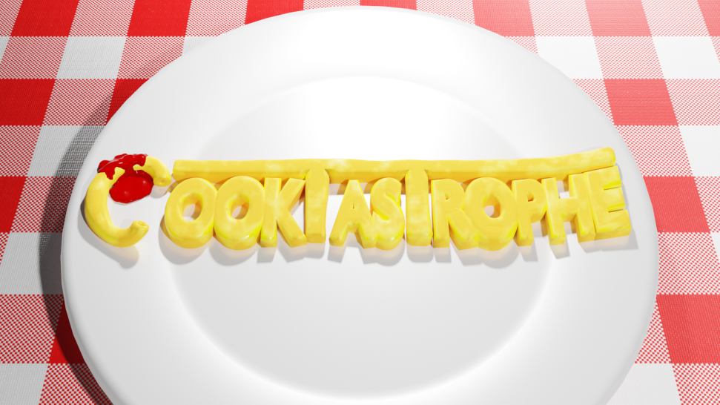

VR Games have minimal User Interface elements aside from the world around them, so most UI will come in the form of small popups that show the progression of a process, or the patience of a customer:

# System Architecture

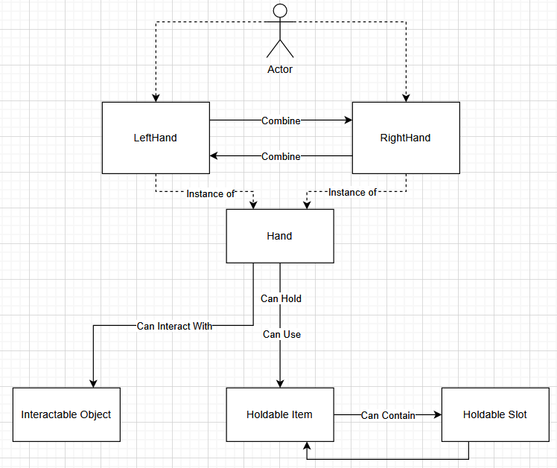

# System Evolution

Over time, the difficulty will increase (more customers, reduced total customer patience, etc). As the game progresses, difficulty will continue to increase until the player gets a game over